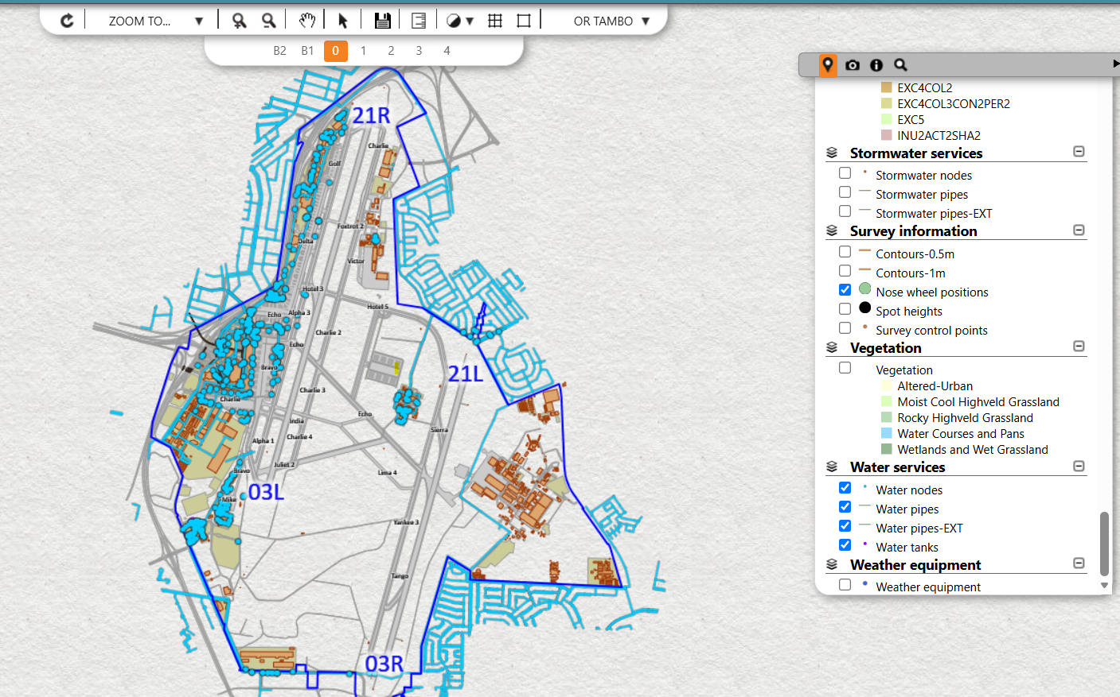
- GIS Layout of the OR Tambo water service

